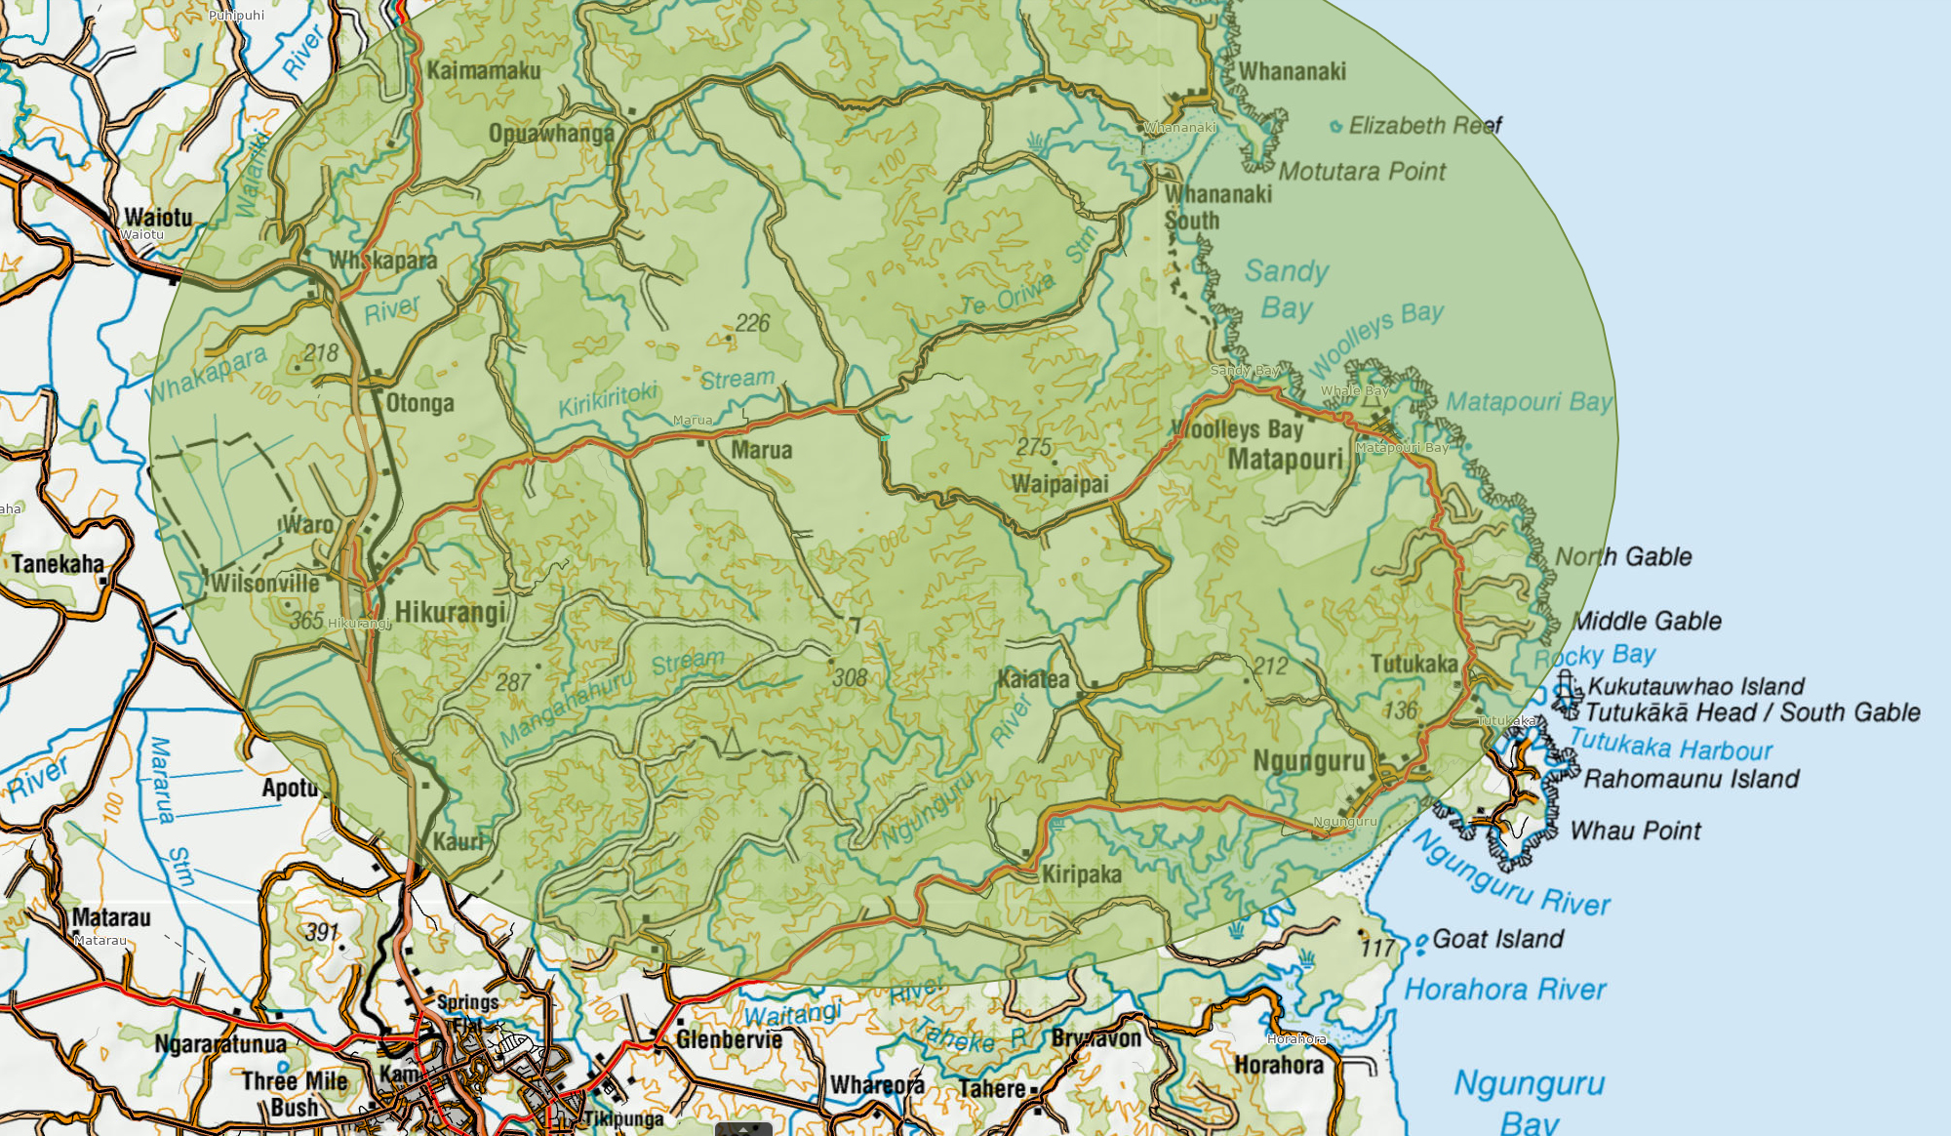
Approximate Delivery Radius: Heaven’s Brewery

